Power BI Assignment 2 – DAX & Data Visualization
Calculated Columns:
● Create a Calculated Column for 'Category Type': Add a calculated column in the Order Details table that combines the 'Category' and 'Sub-Category' columns into a single 'Category Type' column.
Formula:
Category Type = Order_details[Category]&"-"&Order_details[Sub-Category]

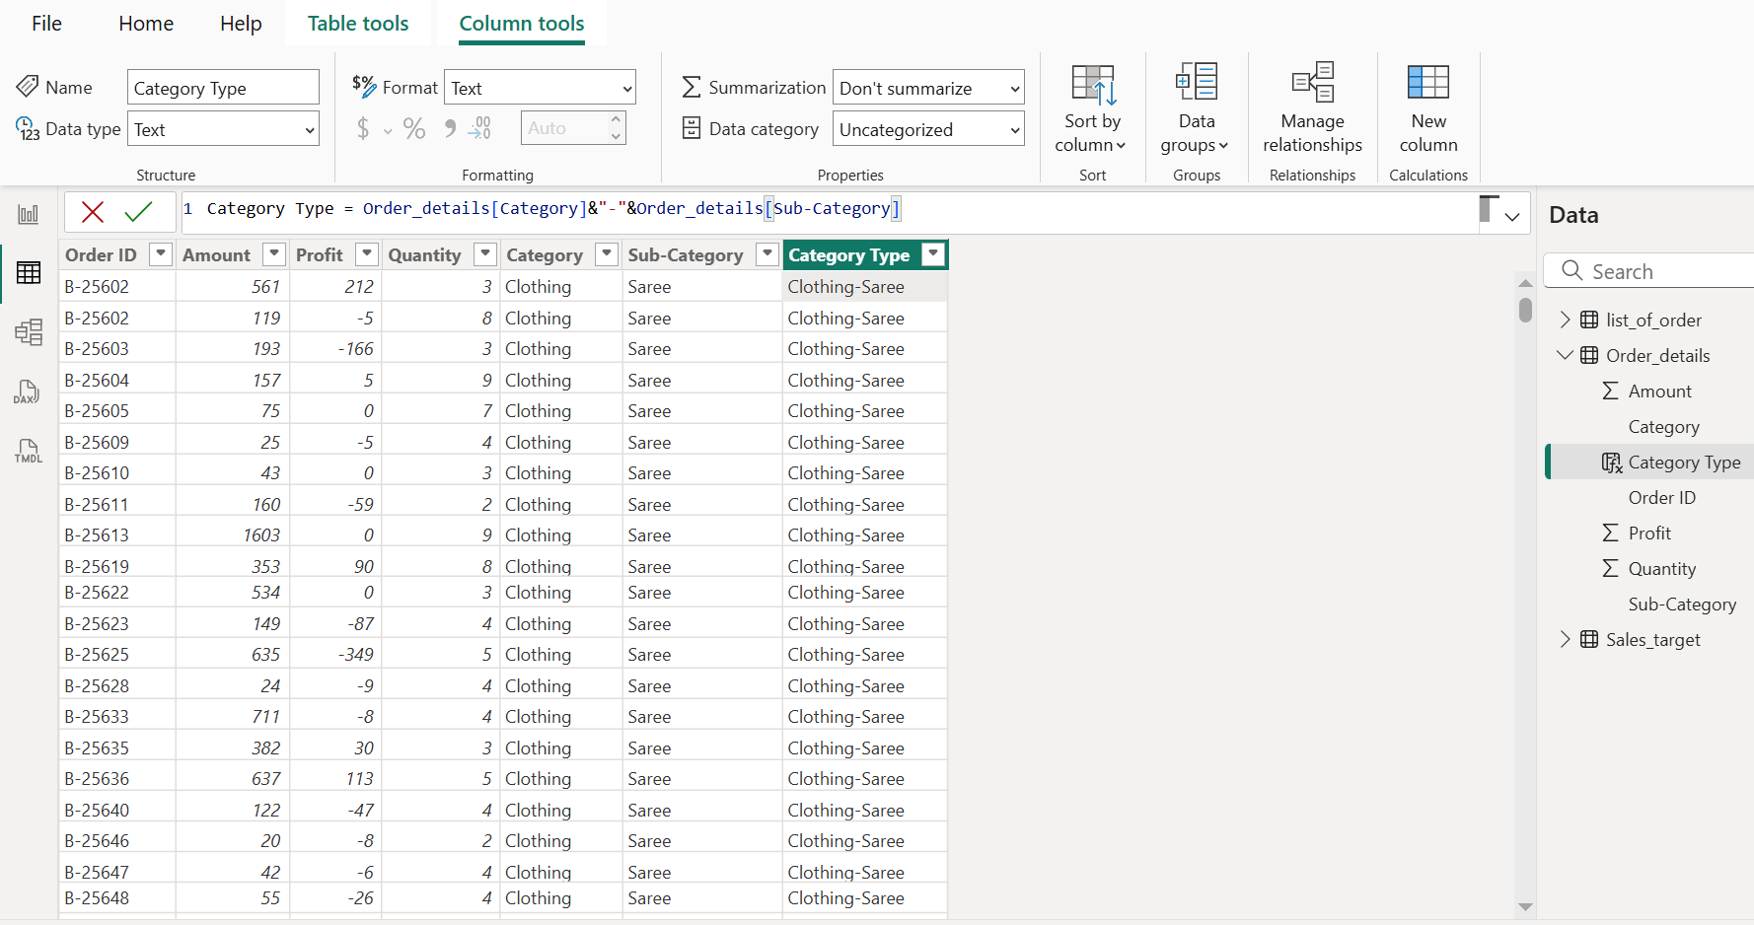
● Calculate Revenue per Order in Order Details Table: Create a calculated column in the Order Details table to compute the revenue (Amount * Quantity) per order.
Formula:
Revenue = Order_details[Amount]*Order_details[Quantity]
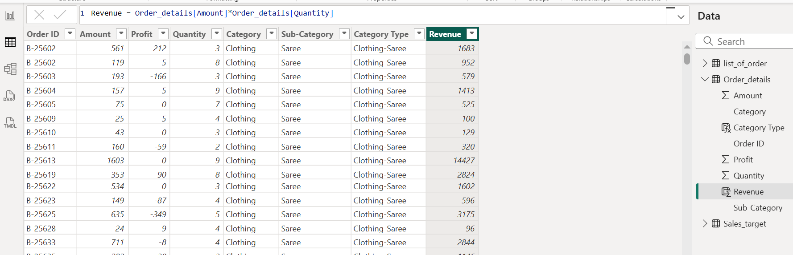
● Create a Calculated Column to Categorize Sales: Add a calculated column named ‘Sales Category’ in the Order Details table that categorizes each order as 'Above Average' or 'Below Average' based on the Amount value.
Formula:
Sales Category =
IF(Order_details[Amount]>AVERAGE(Order_details[Amount]),"Above Average","Below Average")
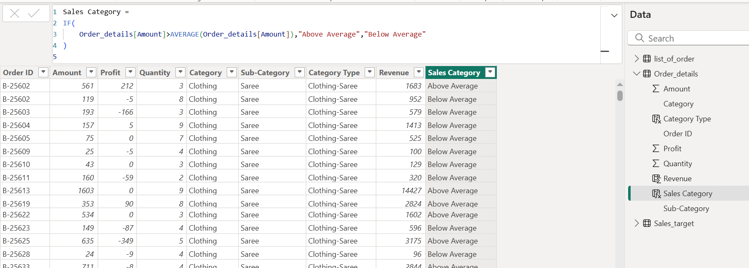
Calculated Measures:
● Calculate Order Count: Define a measure to count the total number of orders in the Order Details table.
Formula:
Order Count = COUNTROWS(Order_details)

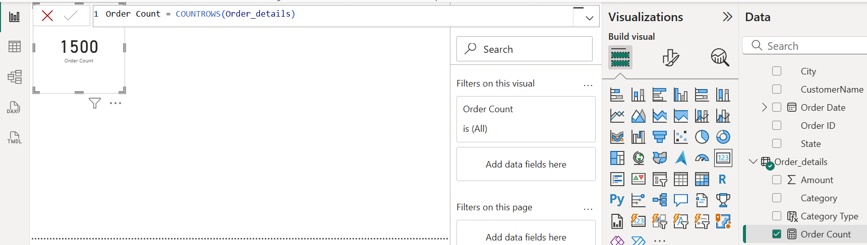
● Calculate Average Profit in Delhi: Create a measure to calculate the average profit for orders placed in Delhi.
Formula:
Average Profit (Delhi) = CALCULATE(AVERAGE('Order_details'[Profit]),'list_of_order'[City] = "Delhi")

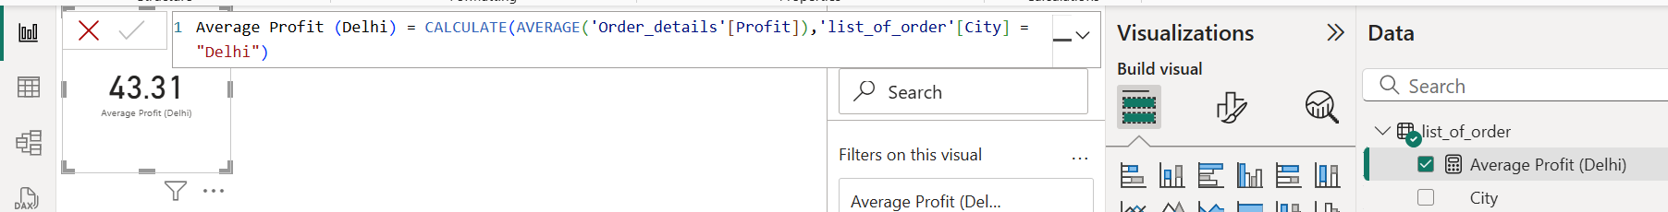
● Calculate Year-to-Date (YTD) Sales: Define a measure to calculate the total sales amount accumulated from the earliest order date up to each order date.
Formula:
YTD Sales =
CALCULATE(SUM('Order_details'[Amount]),DATESYTD('list_of_order'[Order Date]))

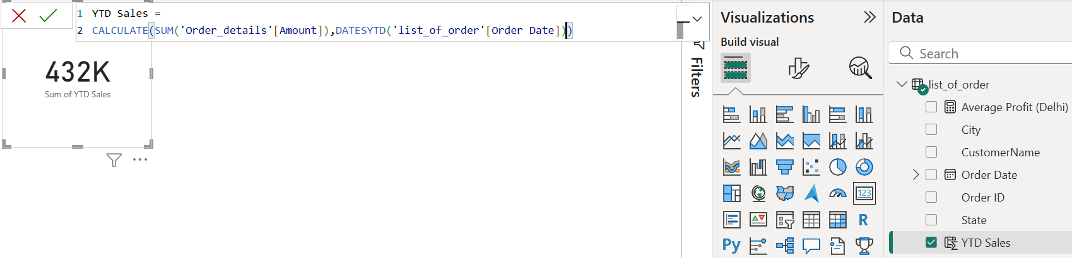

Data Visualization:
Sales Target Achievement by Category: Compare actual sales with sales targets by category using a clustered column chart.
- X-axis Category
- Y-axis Actual Sales = SUM(Order_details[Amount])
- Y-axis Sales Target = SUM(Sales_target[Target])
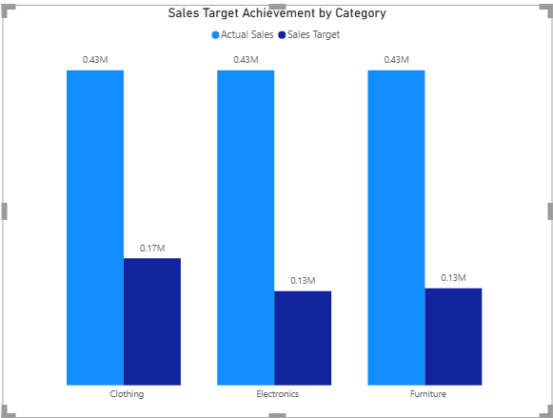
Max Profit Margin by Sub-Category: Analyze the maximum profit margin for each sub-category of products using a donut chart.
- Legend Sub-Category
- Values Max of Profit
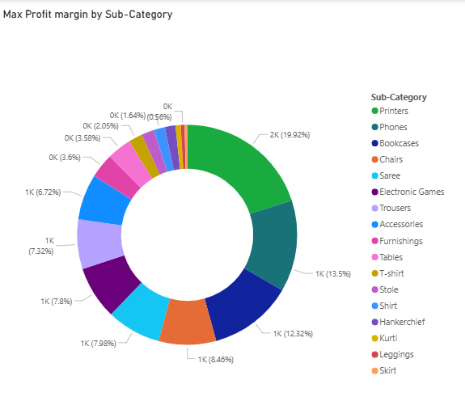
Monthly Sales Trend: Show the trend of monthly sales over time using a line chart.
- X-axis Order Date
- Y-axis Order Count
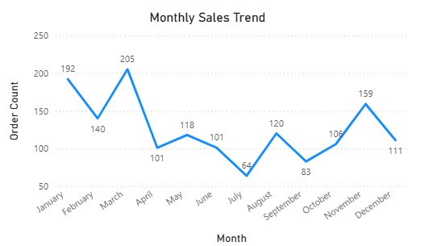
Comparison of Profit and Quantity by Sub-Category: Compare the relationship between profit and quantity sold for different sub-categories using a scatter chart.
- X-axis Quantity
- Y-axis Profit
- Legend Sub-Category
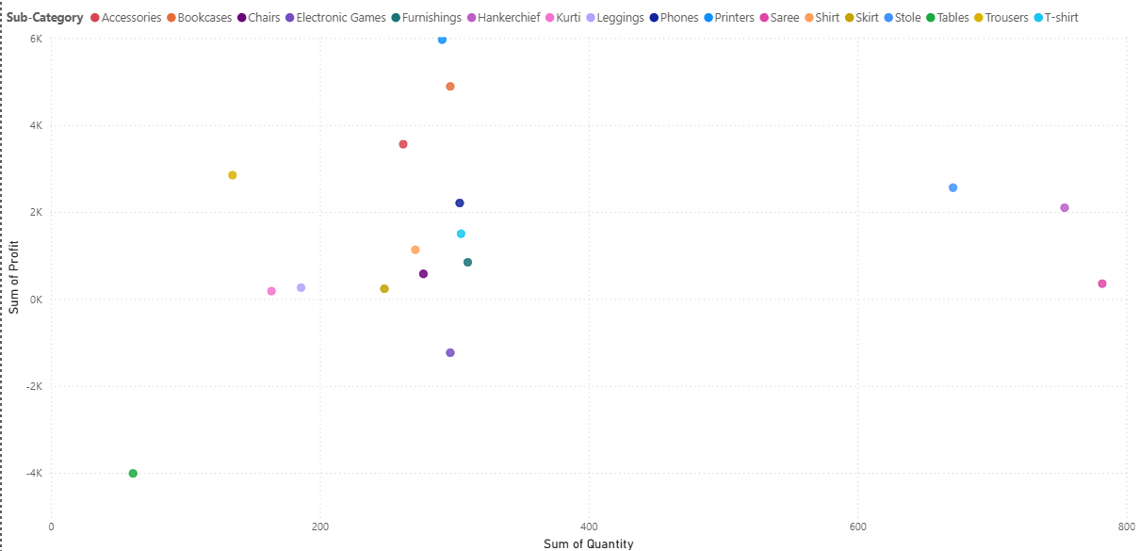

Comparison of Total Sales Amount and Target: Create cards to succinctly display the total sales amount alongside the sales target for quick comparison and analysis. Also, create a multi-row card to display the minimum target for each segment.
- Step 1: Card FieldsTotal Sales Amount
- Step 2: Card FieldsSales target
- Step 3:CardFieldsTarget & Category
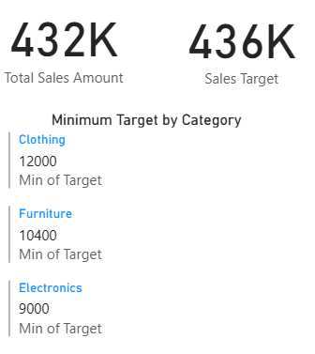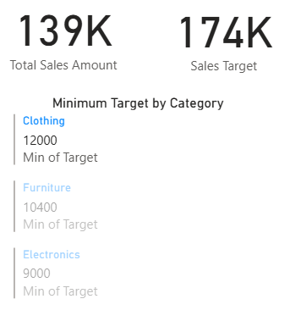
Sales Performance Matrix: Build a matrix view to analyze how actual sales compare to sales targets across different categories and months.
- Row Month Of Order Date
- ColumnCategory
- ValuesActual Sales & Sales Target

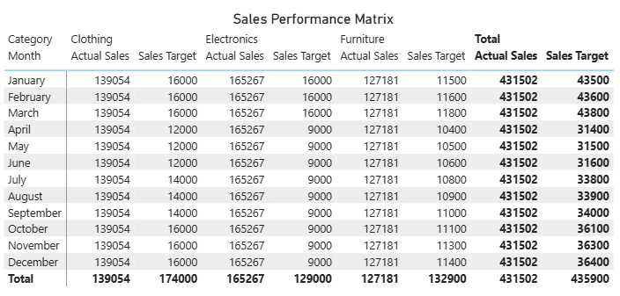
Geographic Sales Analysis: Visualize total sales on a map by city to identify regional sales patterns.
- LocationCity
- Bubble SizeSum Sales
- Tooltips State,Profit & Quantity
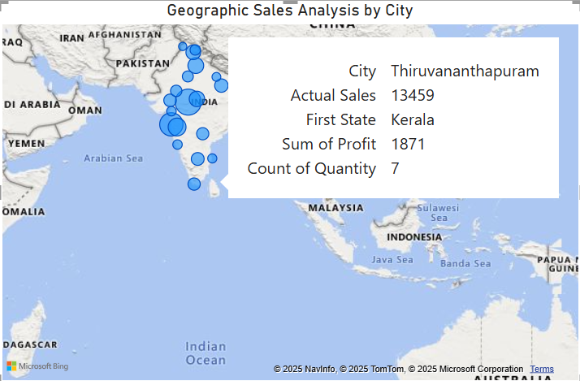
Sales Distribution by Sub-Category: Represent the sales distribution across different sub-categories using a treemap.
- CategoryCategory
- ValuesSales
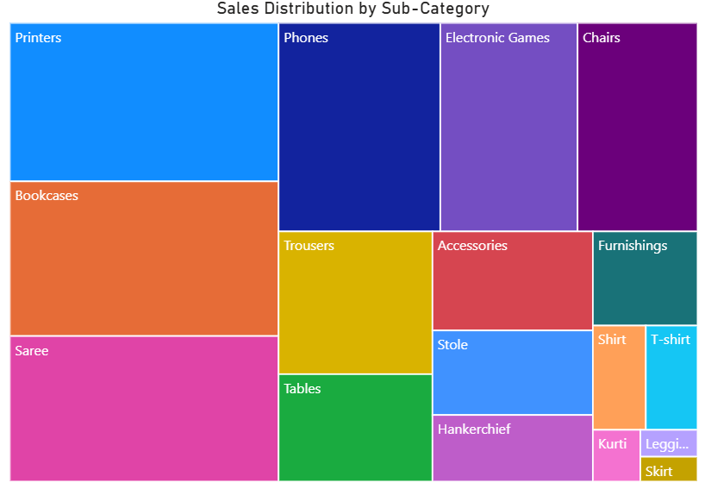
Order Count Analysis by State: Create a funnel chart to visualize the distribution of order counts across different states.
- Category State
- ValuesOrder Count
